Practical No:02
Configuration AAA
- Network
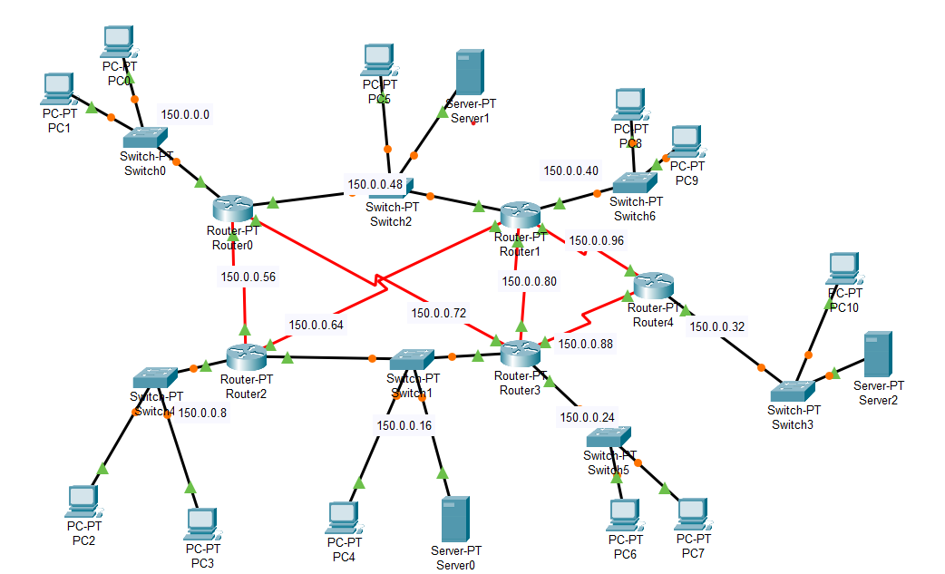

- Tacacs server
- command ip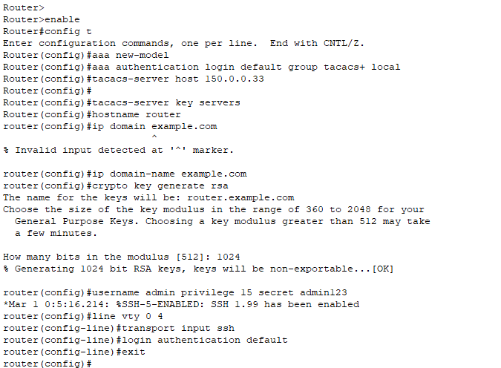

- AAA server Tacacs service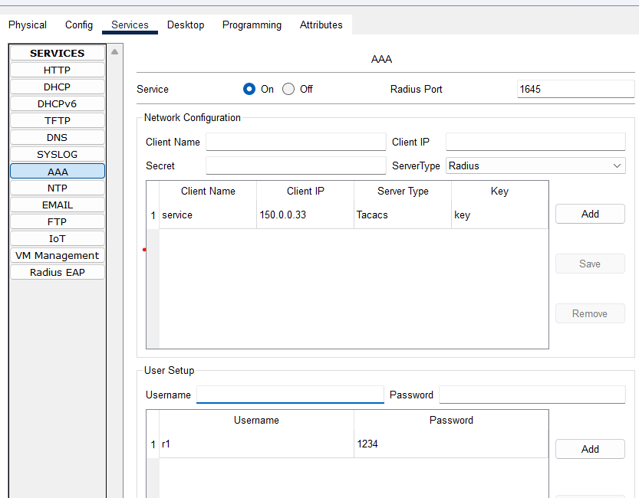
- Access On PC’S
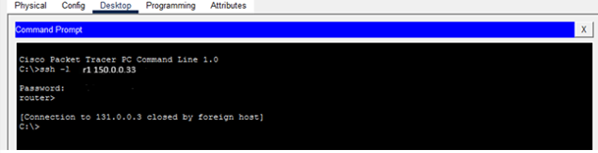
- Radius Server
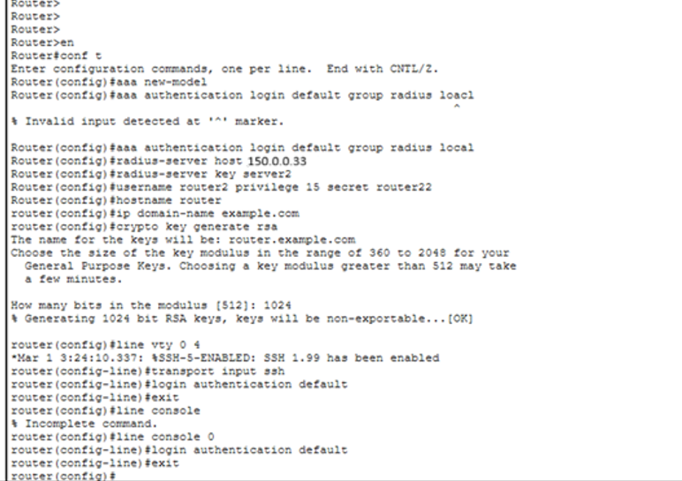
- AAA server Radius Service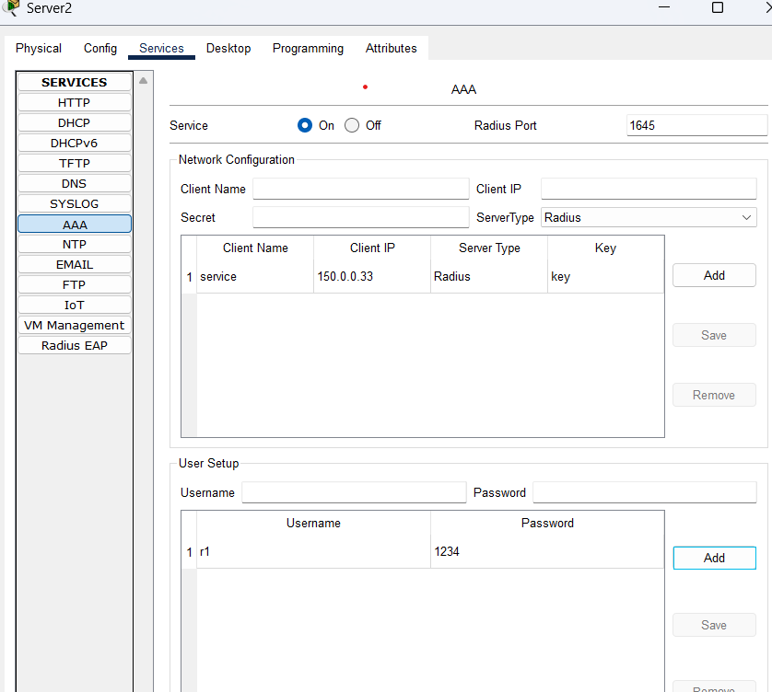
- Access on PC’S


